**Title of work:** ClassLabPart02

**Name:** Shani Patel

**Section Code:** NEE

**Date submitted:** 03/06/2021

**Professor's name:** Tevin Apenteng

**Class Diagram**

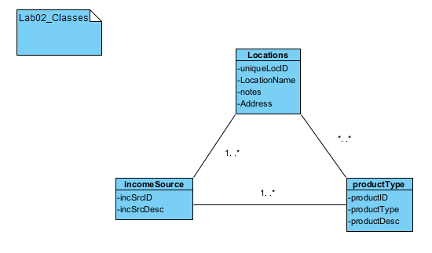

**Sequence Diagram**

1. **Create an Income Source**

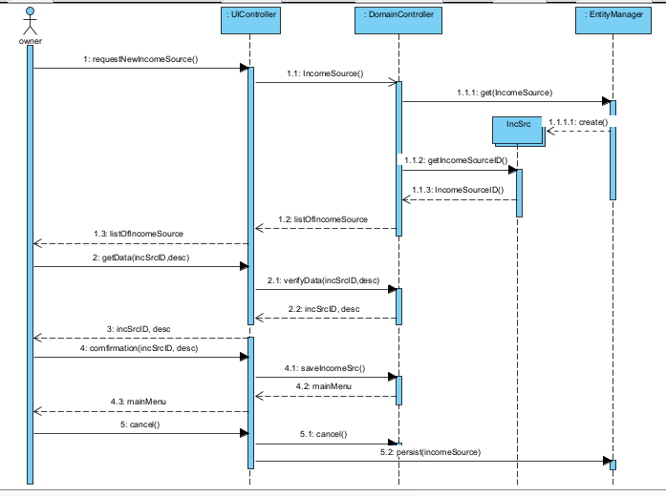

1. **Change an Income Source Description**

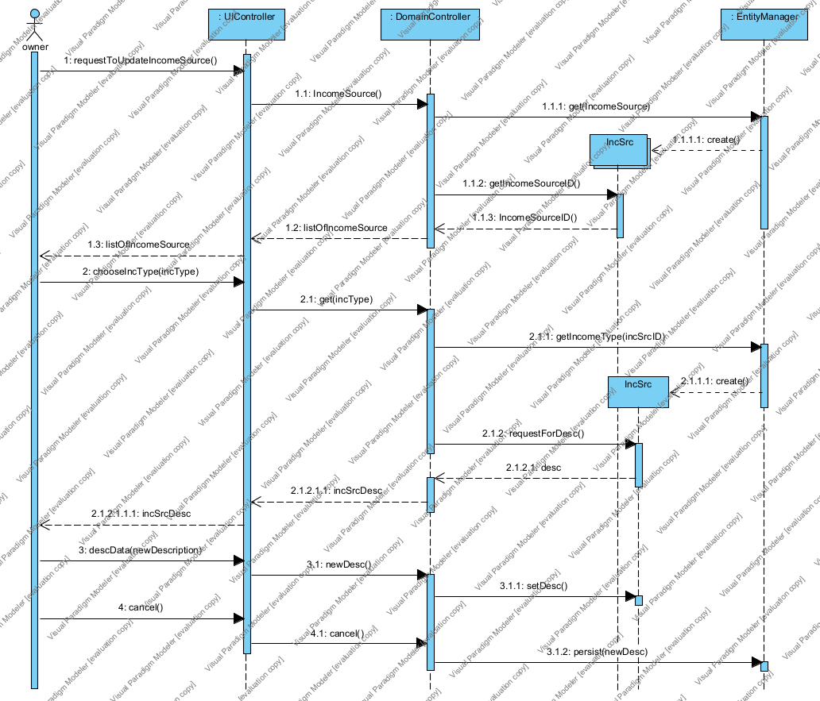

1. **Query all income sources and their descriptions**

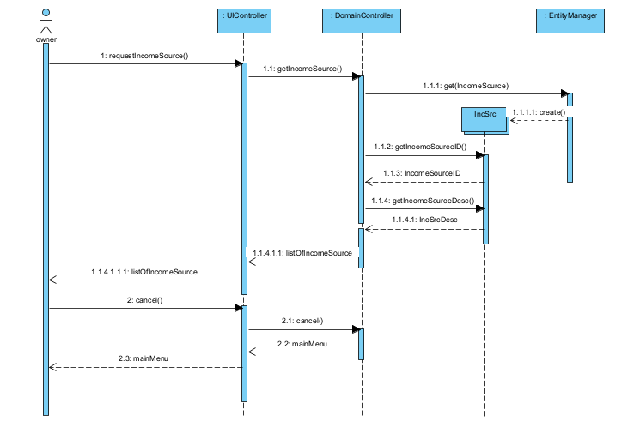

1. **Create a location**

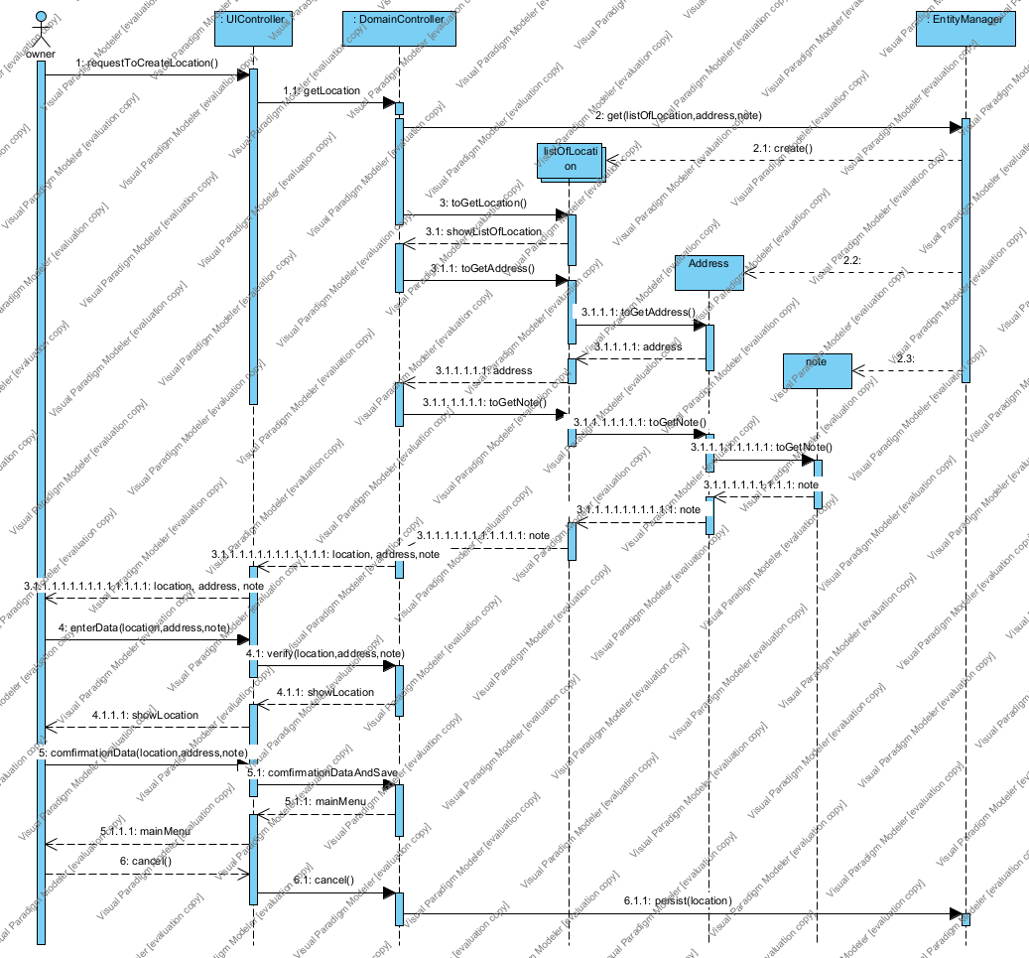

1. **Query all locations**

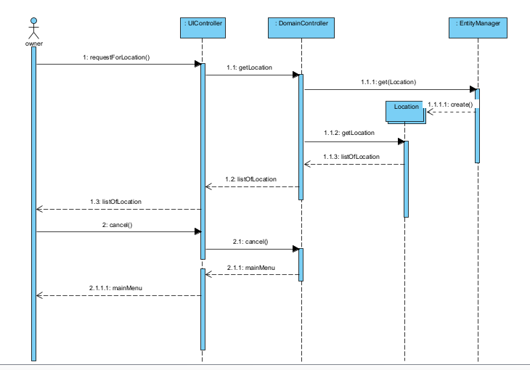

1. **Create a product type**

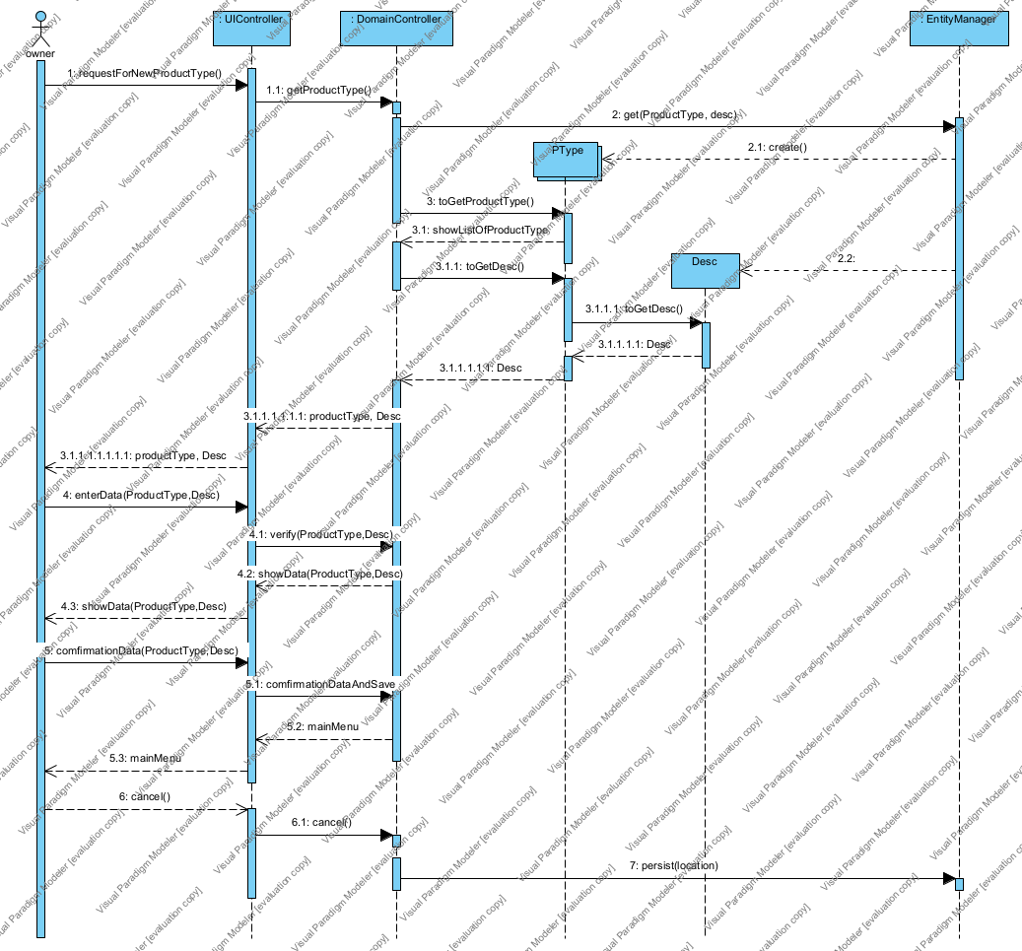

1. **Query all product types**

